

Schedule facilitating System

Group 2:

Joshua Bates

Kyle Walden

Bin Fan

Group 4:

Paul Schulz

Michael Whalen

Deana Qiao

Group 6:

Gunjan Sharma

Vibhashit Solanki

Alok Narvekar



April 28, 2015

Contents

DEPLOYMENT INSTRUCTIONS 1

WALKTHROUGH 1

Create New Schedule 1

Open a Schedule 6

Import a Schedule 9

Edit / Using Edit Panel 13

Check Conflicts 20

Search 22

Change Views 24

Change the Theme / Theme Preferences and Style 27

Final Notes 36

Modify file 36

# DEPLOYMENT INSTRUCTIONS

It is necessary to have the Java Runtime Environment (JRE) in order to run the program, which can run on any operating system (i.e. windows, linux, mac, and etc…). In addition, only csv files can be imported and used with the program.

# WALKTHROUGH

## Create New Schedule

1. Launch application
2. Click the “New” button located near the bottom in the “OPTIONS” panel.

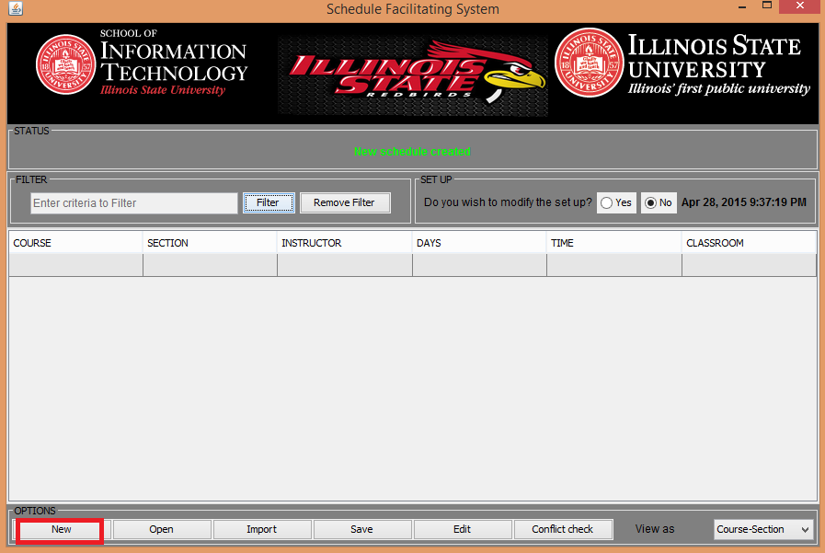

1. Next click the “Edit” button.

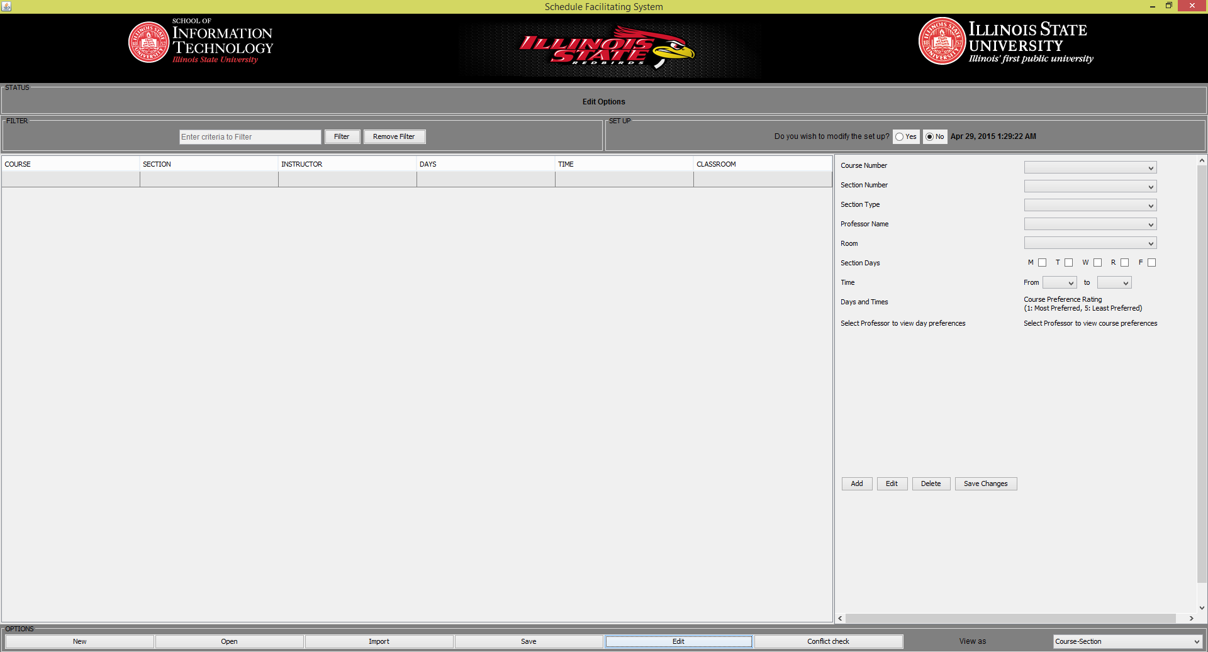

1. In the edit panel, the user can add, edit, delete, and save changes of the Professor’s preferences. The screenshot below is an example of adding data.

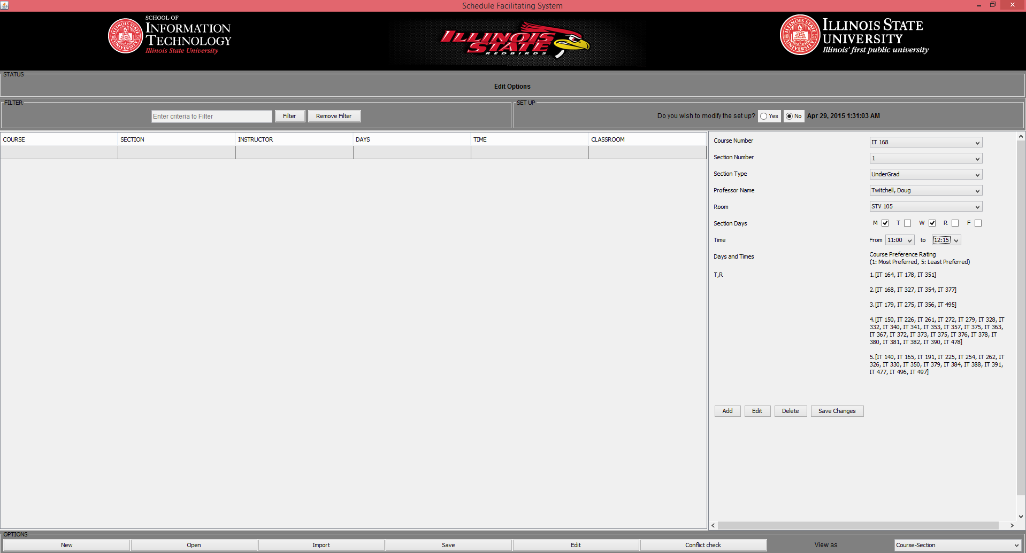

1. After adding the data, please click the button called “Add” at the bottom of the edit panel. The result should show on the schedule table on the left hand side.

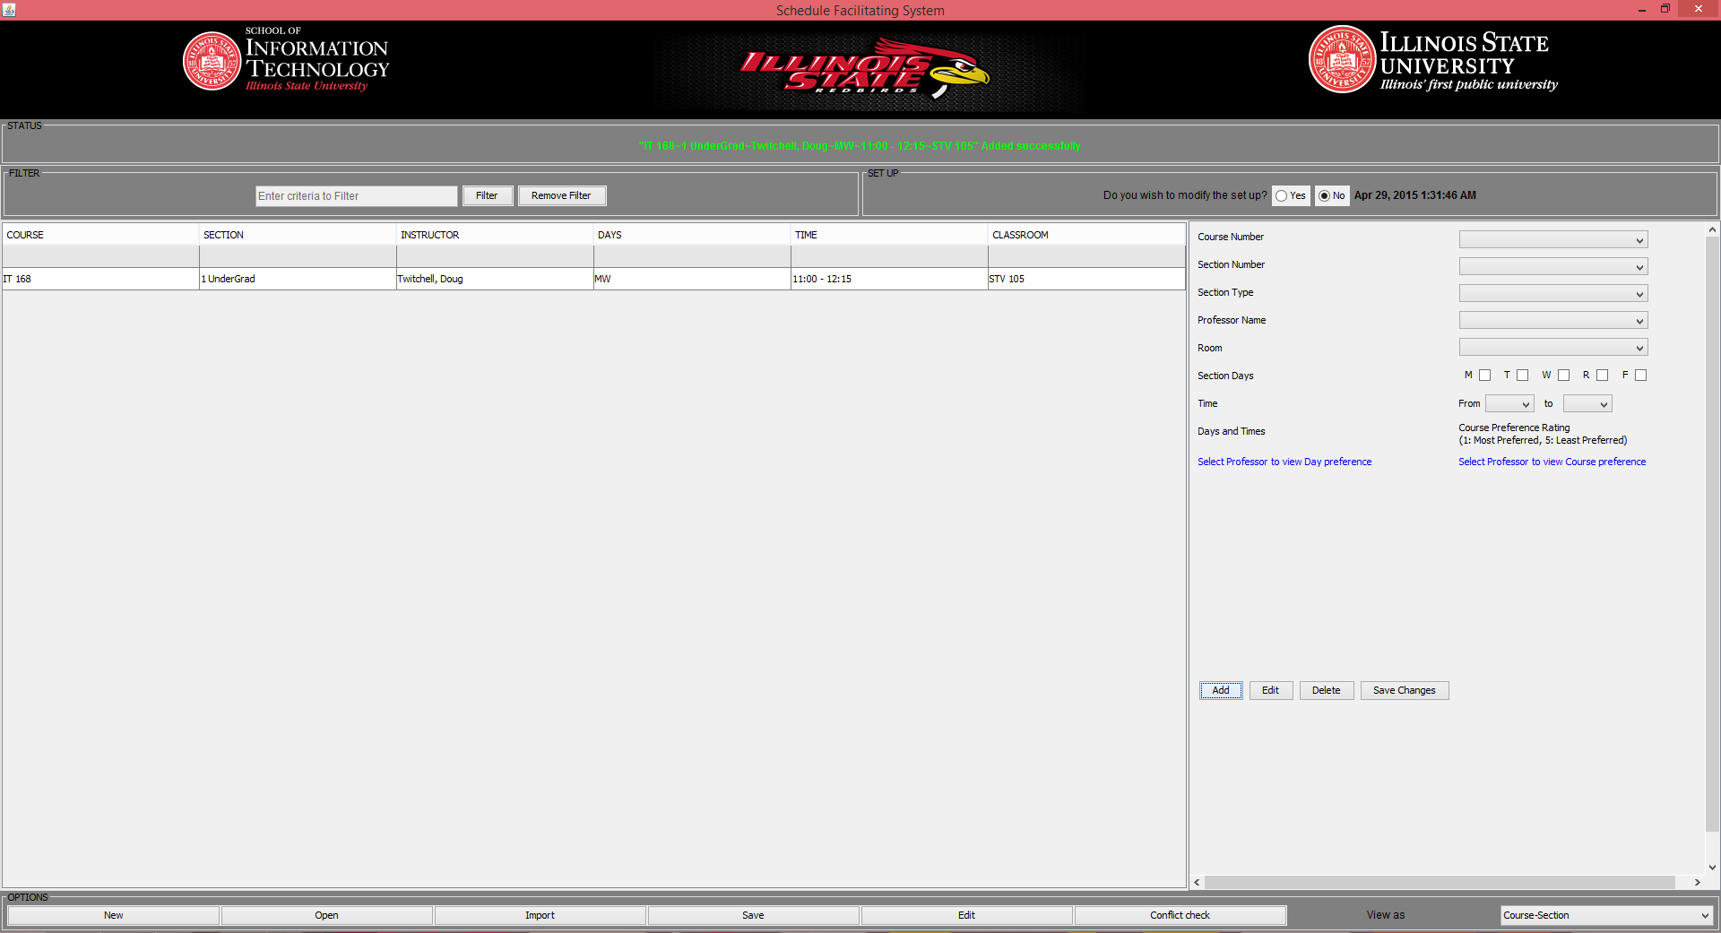

1. After confirming that the data being presented on the left hand side matches the data you put in on the right hand side please click the “Save” button at the bottom (in the “Options” panel). A pop up menu will appear prompting you to rename the file.

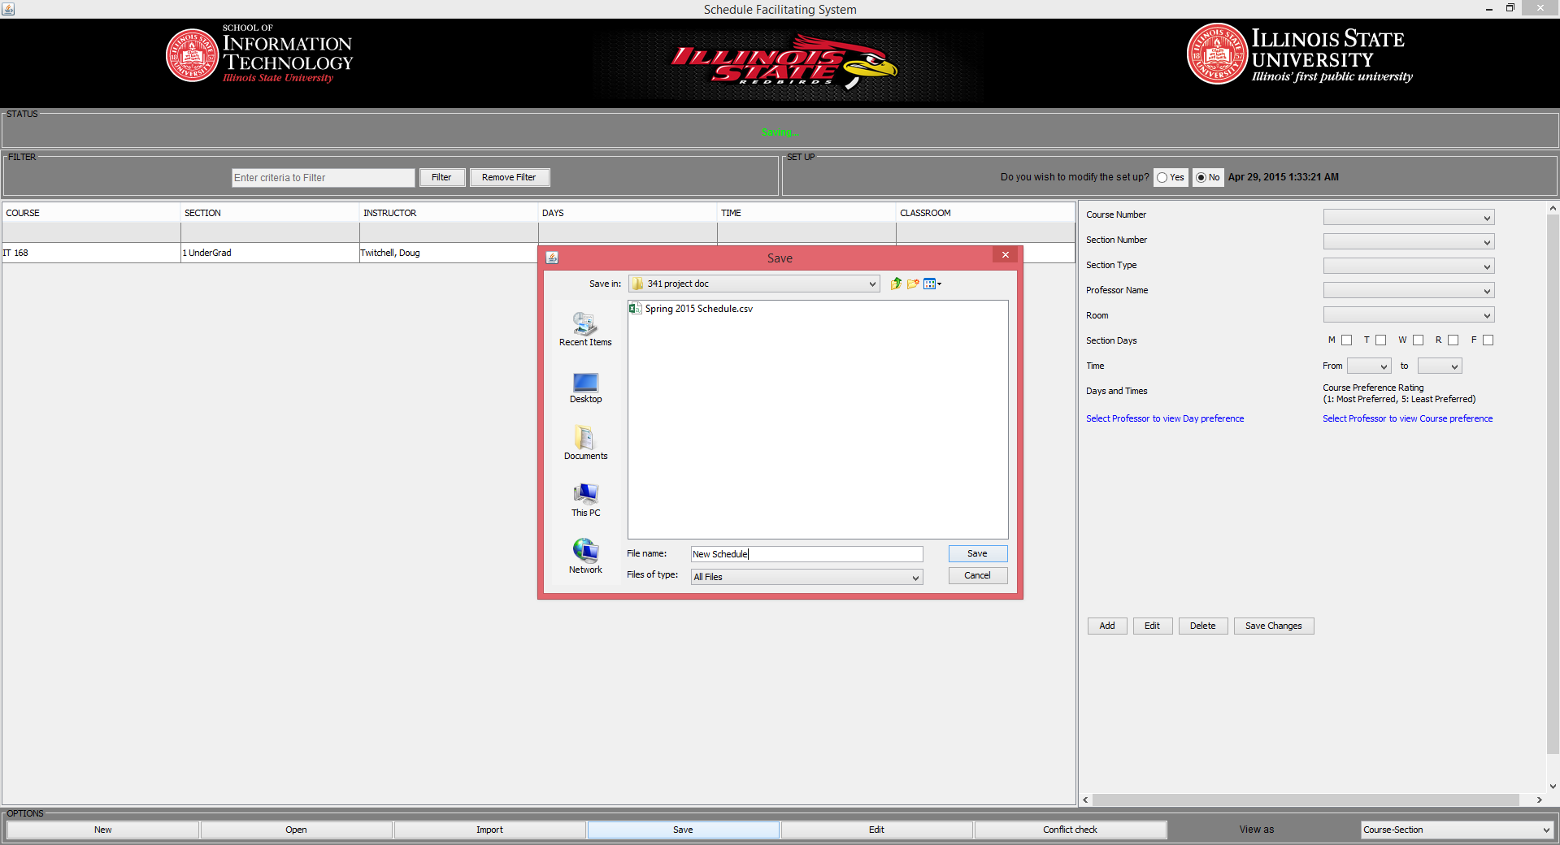

1. After you rename the file please click “Save”. At the top in the “Status” bar, you should see green colored text with saying that what you saved has been successful along with the location path.

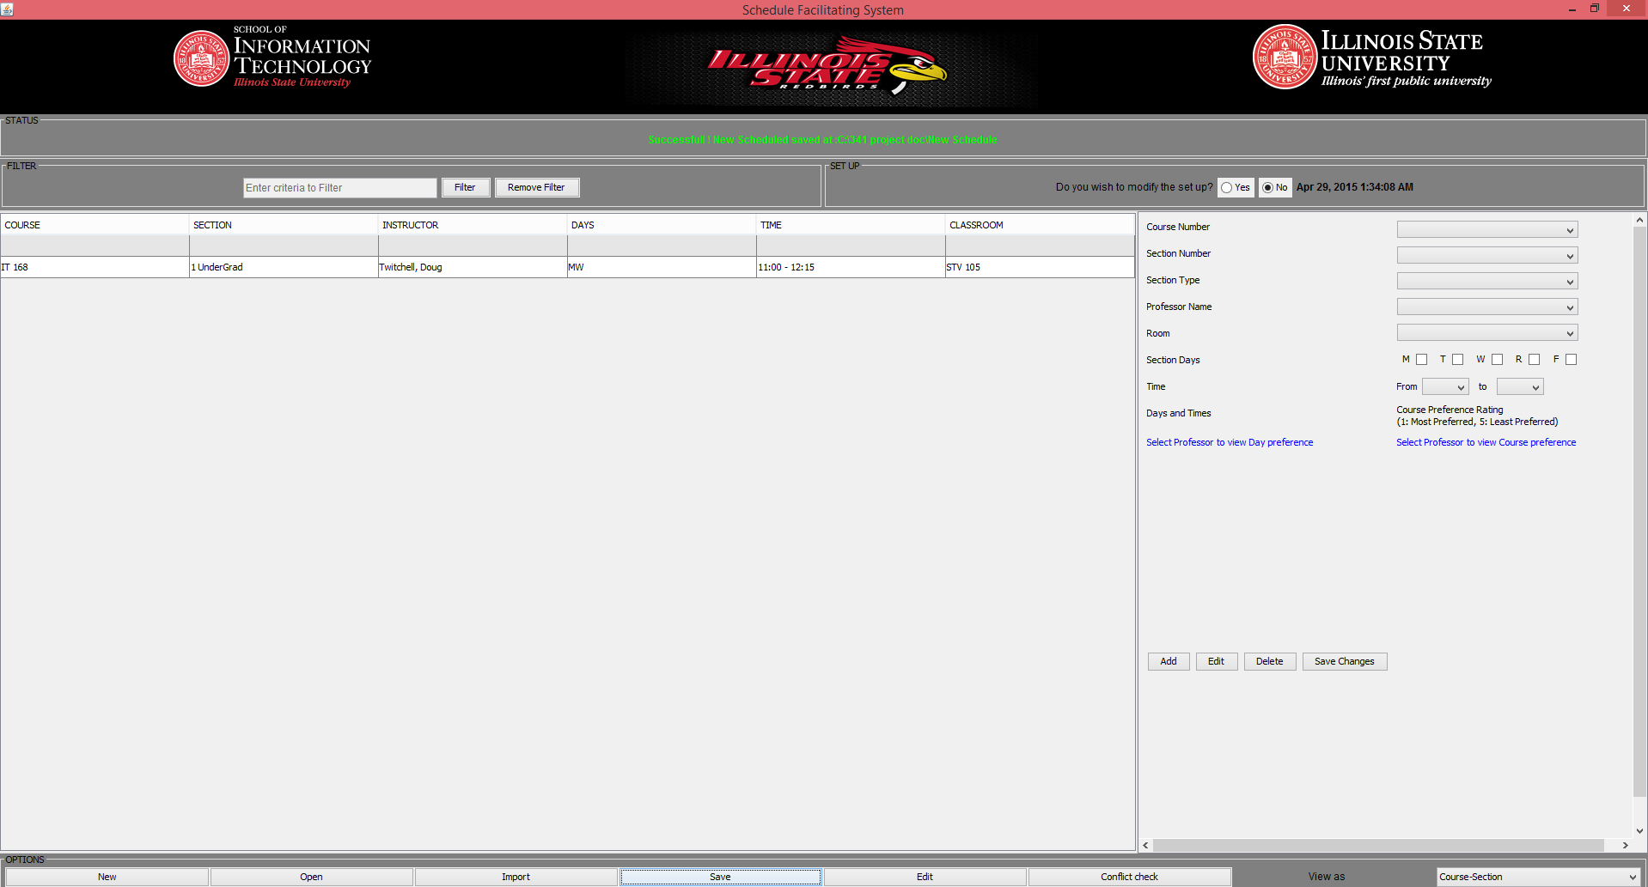

1. It is also important to note that the user can come back to the file by clicking **OPEN** and selecting this file. **BUT** it is necessary to **RELAUNCH** the application before opening it.

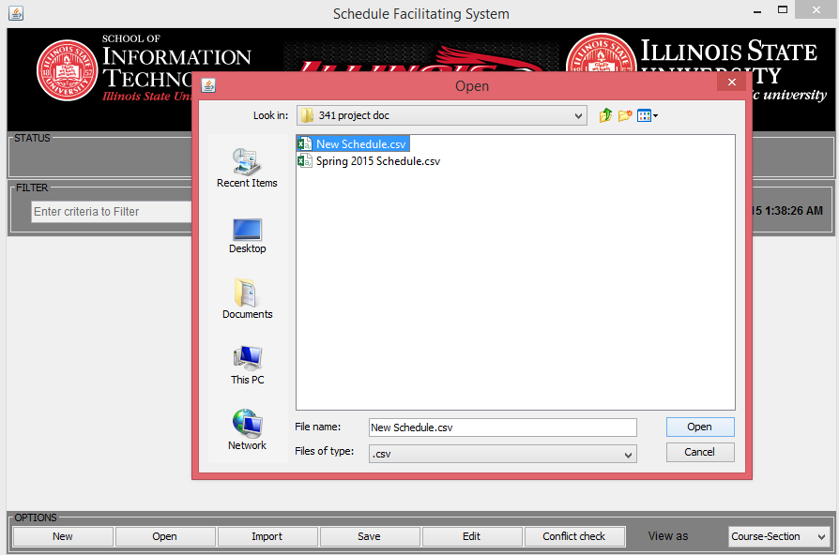

1. Afterwards, the previous schedule will load into the Schedule table. Which will look similar to the example below.

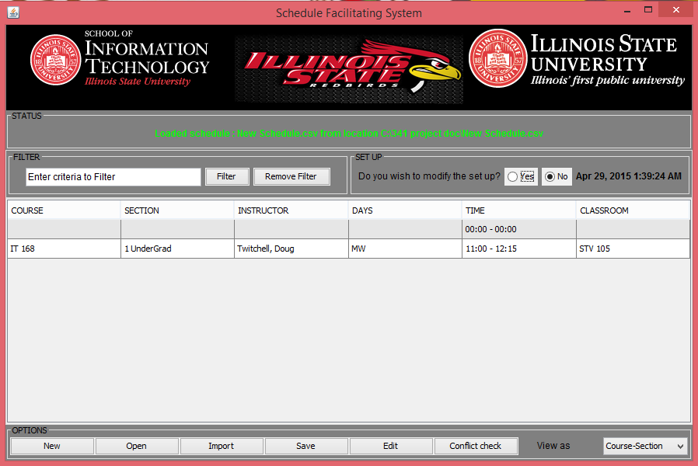

## Open a Schedule[1]

1. Launch application
2. Click the “Open” button located near the bottom in the “OPTIONS” panel.

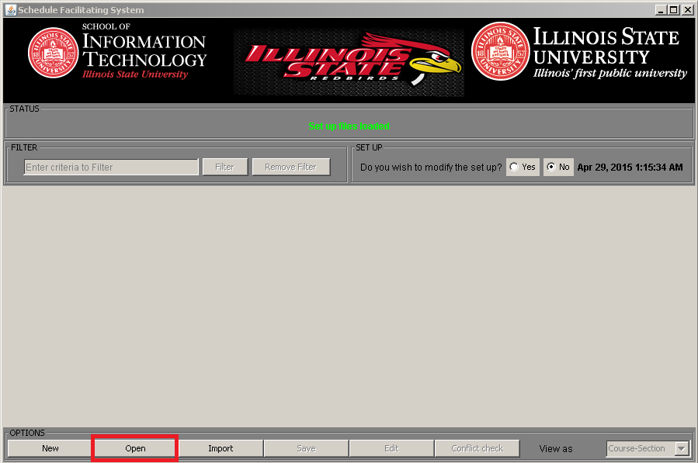

1. Next, choose the csv schedule file you would like to open. In the example below we chose a csv file from the “Setup files” folder (location is “C:SFSystem\Setup files\Schedule.csv”).

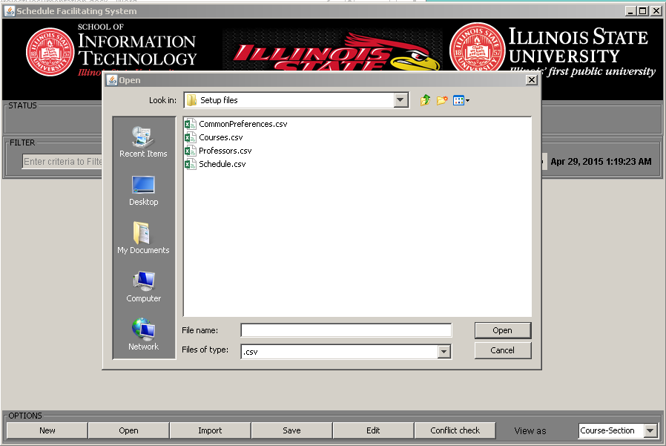

1. Afterwards click the open button and you will be able to see the schedule visually displayed as a table.

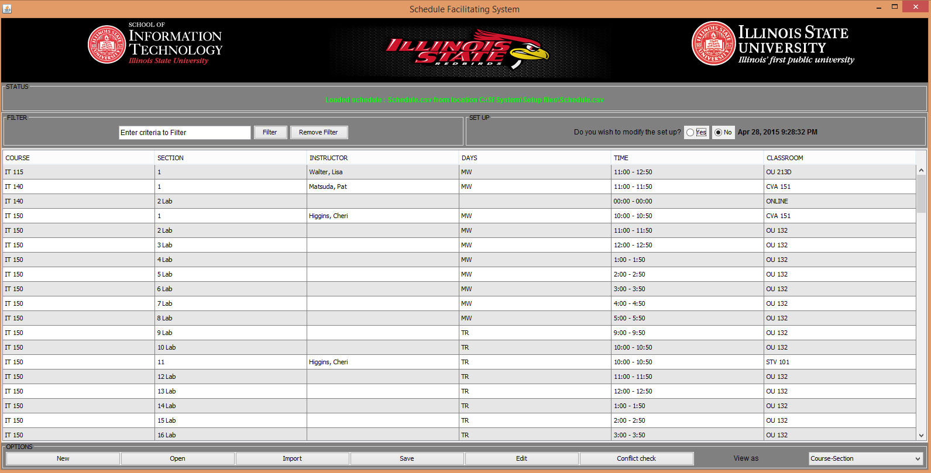

**OR**

1. You can also choose a csv file from any other folder location. In the example below the file is being loaded from the location "C:\Files Saved\Courses\IT 341.05 - Object-Oriented\Project\files\Spring 2015 Schedule.csv". However if you choose to load from a different location than the “Setup files” folder, it is NECESSARY that you have SCHEDULE as a keyword in the file name.

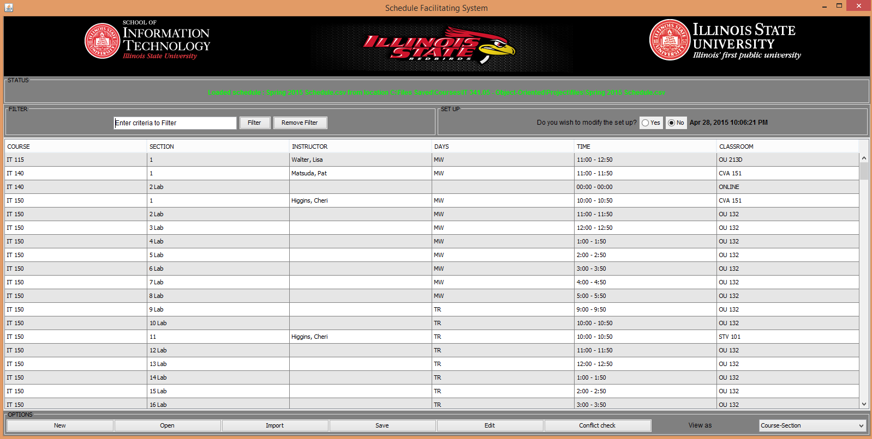

## Import a Schedule[2]

1. Launch the application.
2. Click the “Import” button located near the bottom in the “OPTIONS” panel.

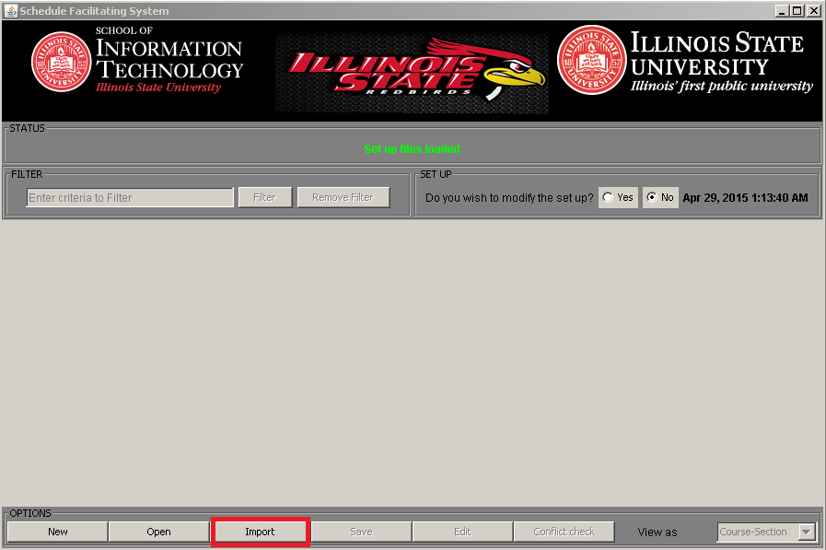

1. Select a csv file to import.

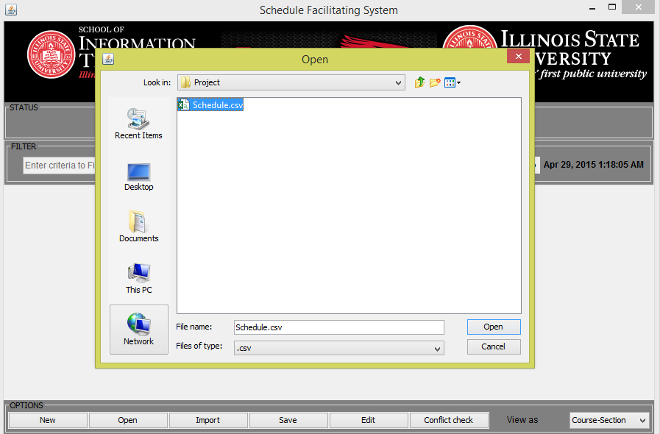

1. Afterwards click “Open” and the schedule will show to be imported.

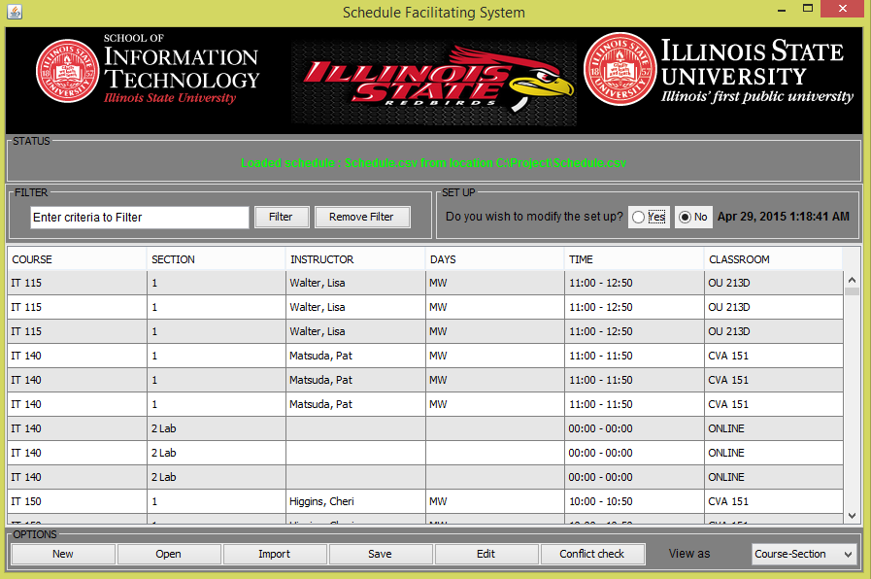

1. Next if you want to save, click save to save the file into a new location and/or with a different file name.

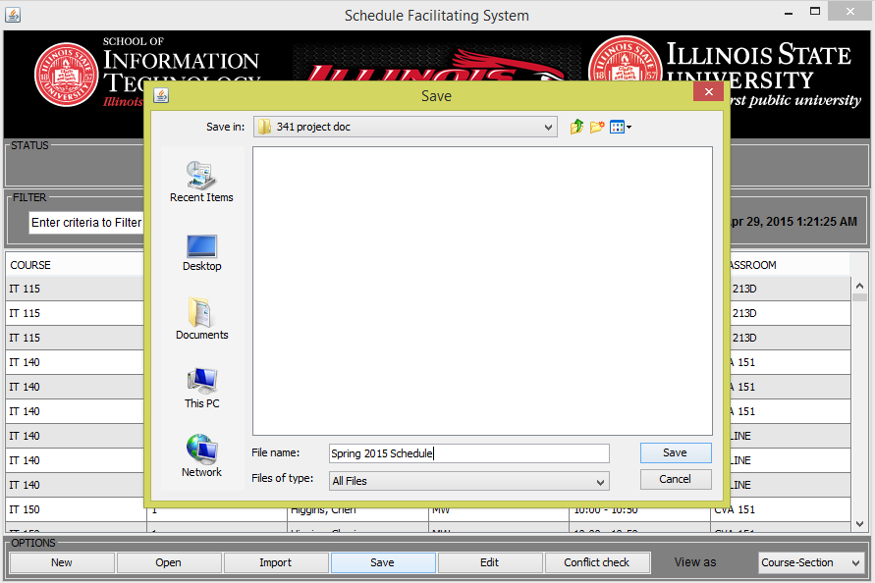

1. Then it will show the file being saved with the default csv extension.

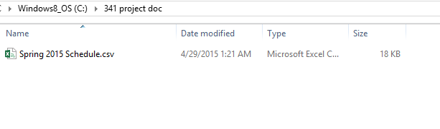

1. Then you will see that the new schedule is saved.

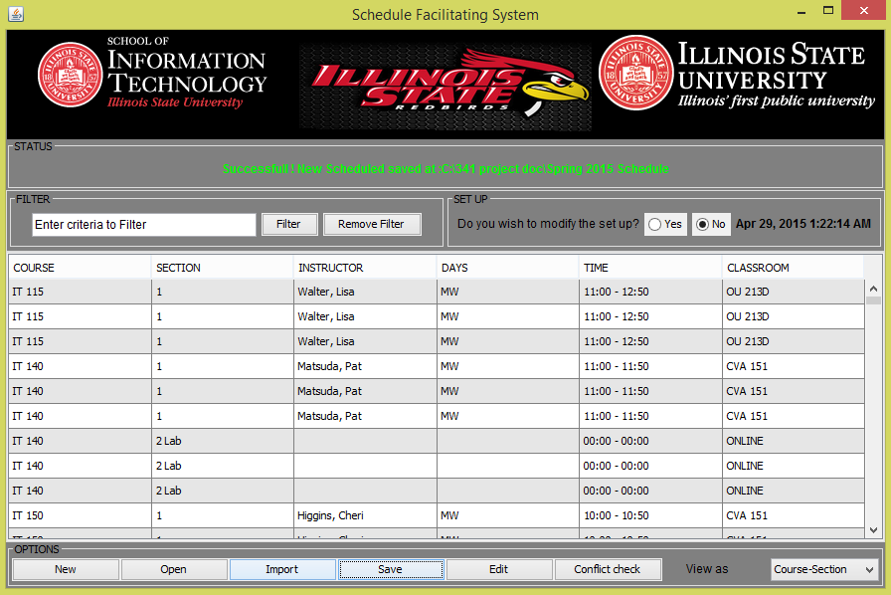

1. If you click save for a second time, it will save in the location with the defined location and specified name that you did for the first time.

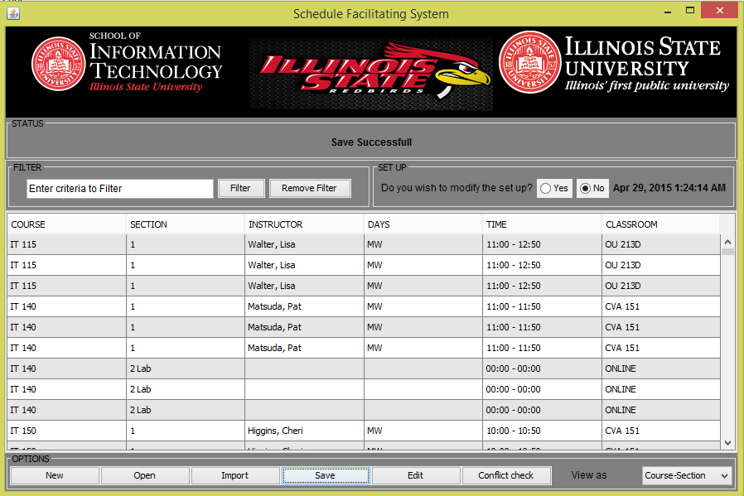

## Edit / Using Edit Panel

1. (Assume Steps 1-4 from “Open a Schedule” are already done.) Click the “Edit” button located near the bottom in the “OPTIONS” panel.

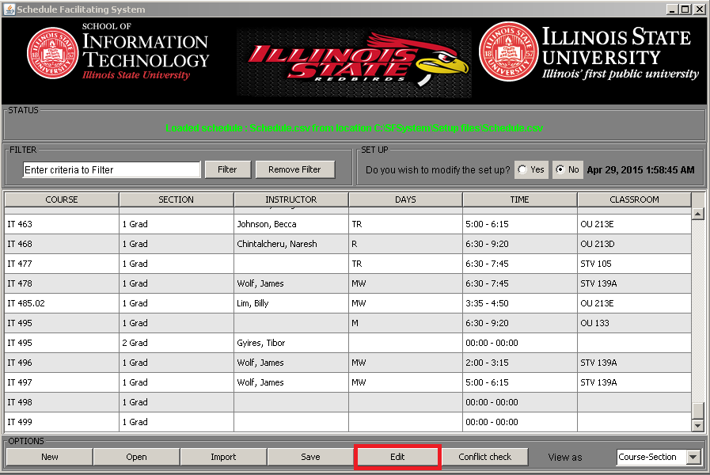

1. After you click “Edit” select a row.

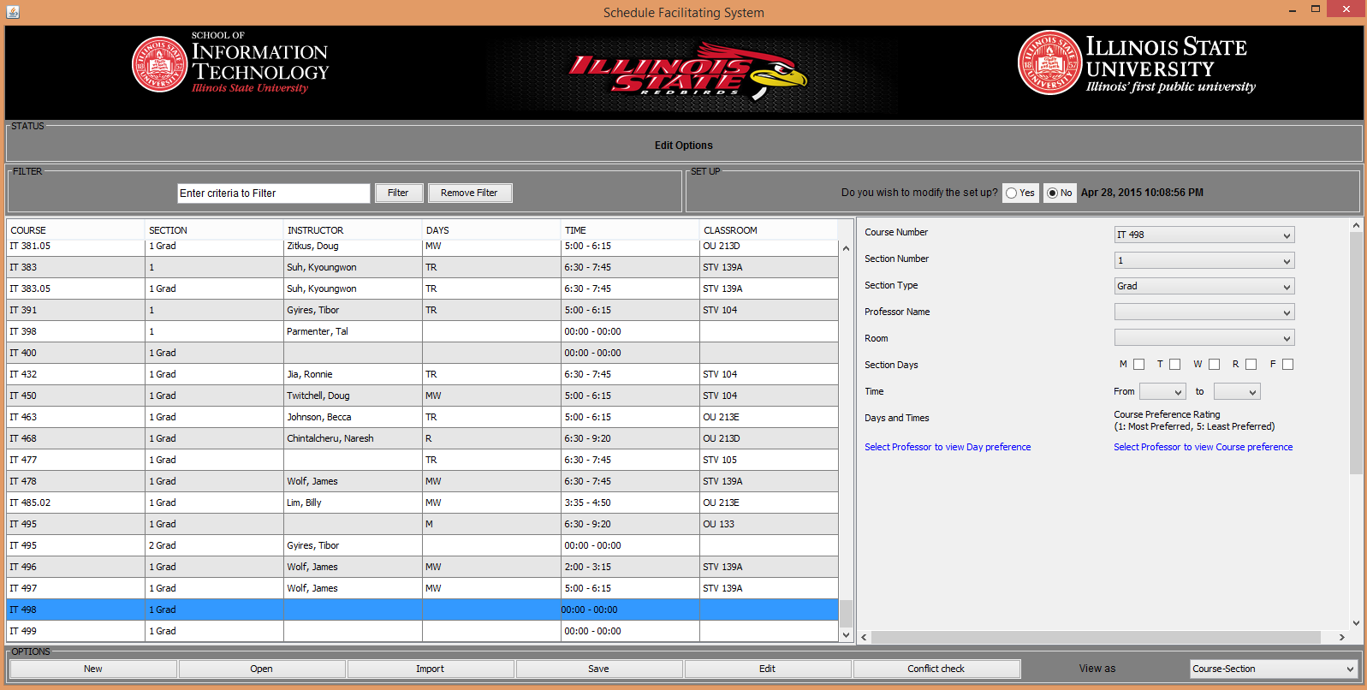

1. Edit the information.

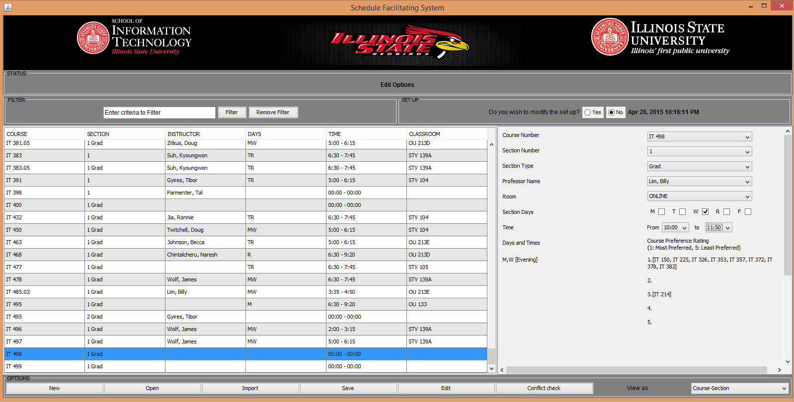

1. When you are done editing, click the “edit” button again in the “Edit” panel.

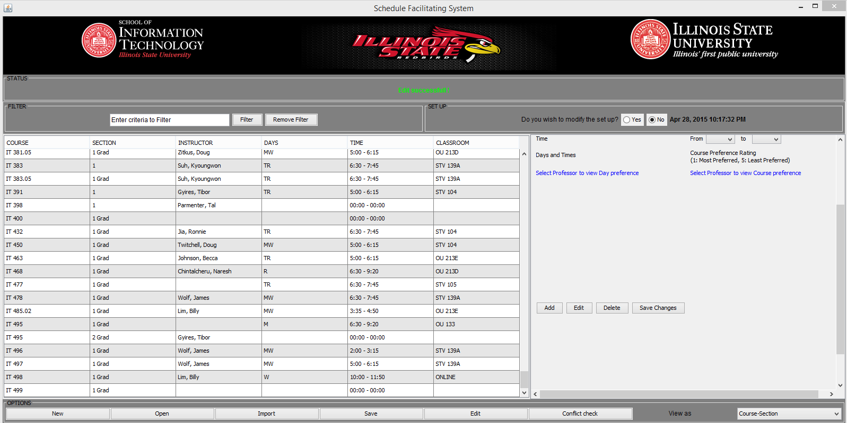

1. After clicking “Edit” in the Edit Panel, please click “Save Changes”.

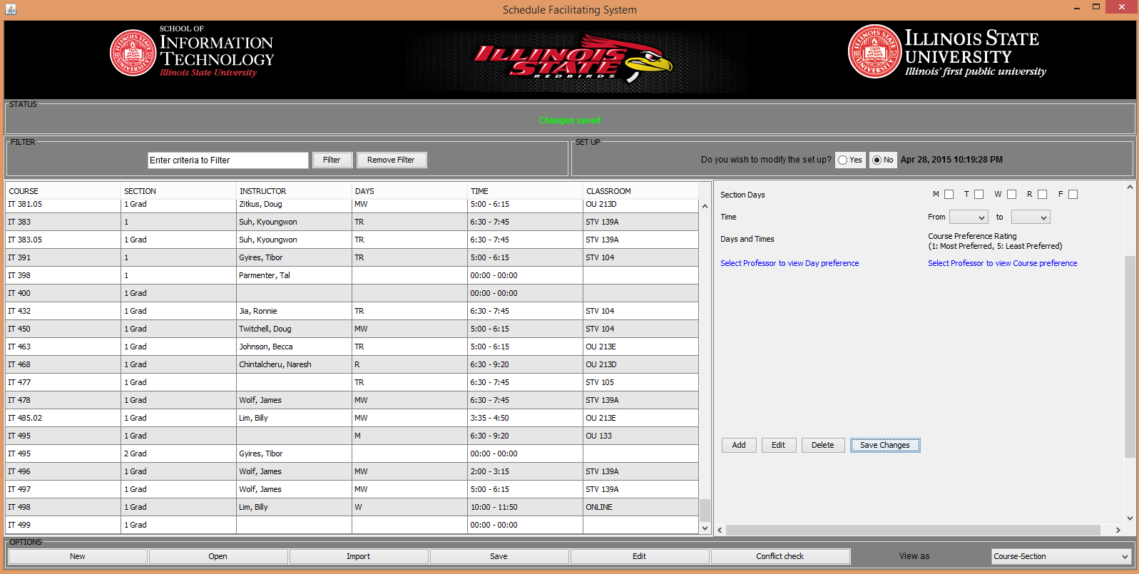

1. **HOWEVER**, it is important to know that if you do not select a row to edit you will get red colored text in the Status panel (notifying to the user that a row must be selected).

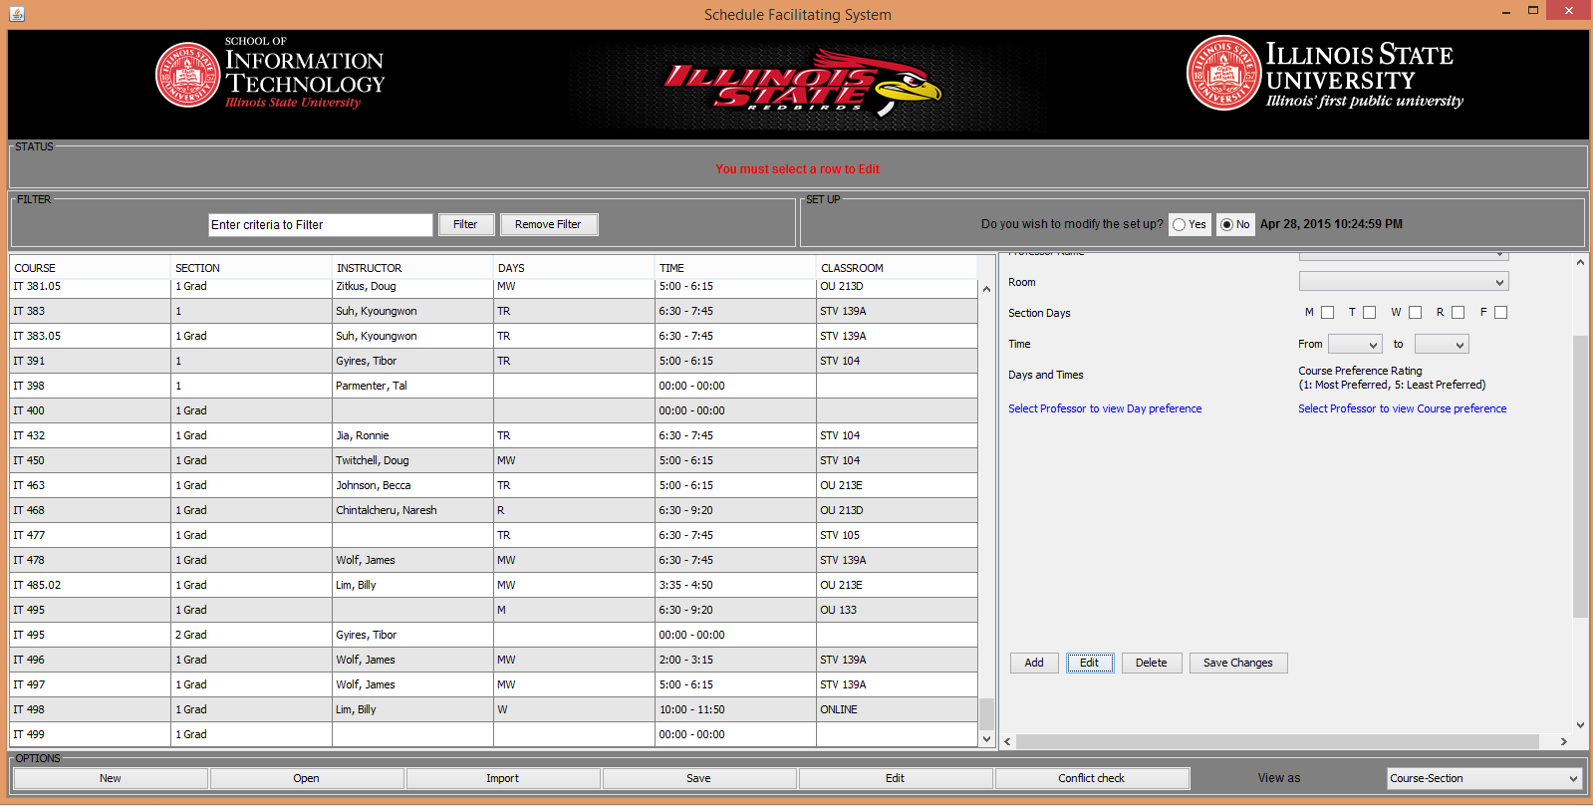

1. The same rule applies if the user does not select a course number to edit.

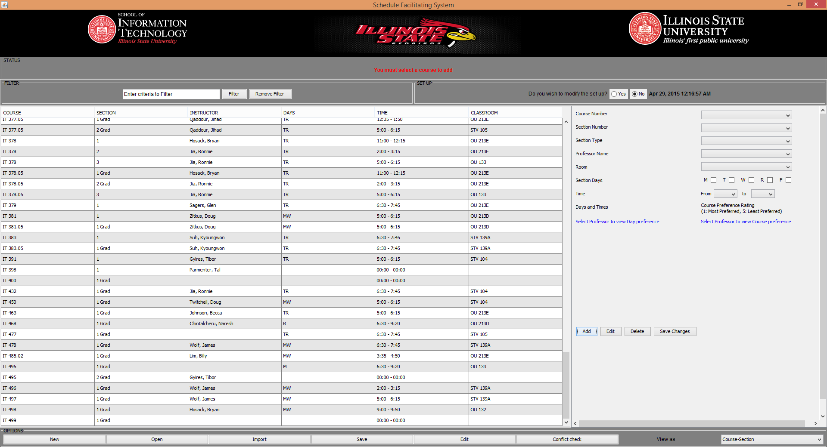

1. **Add a course**, first select a course number to add.

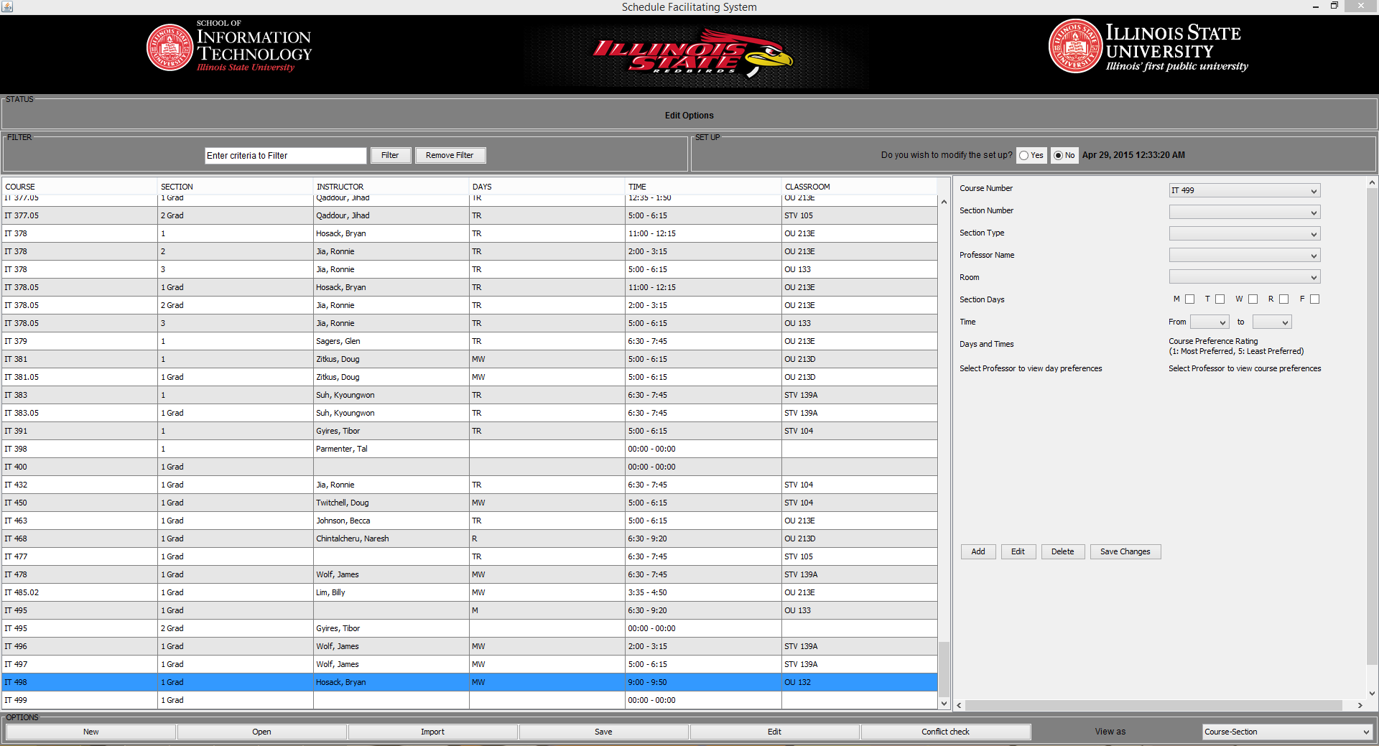

1. Click add.

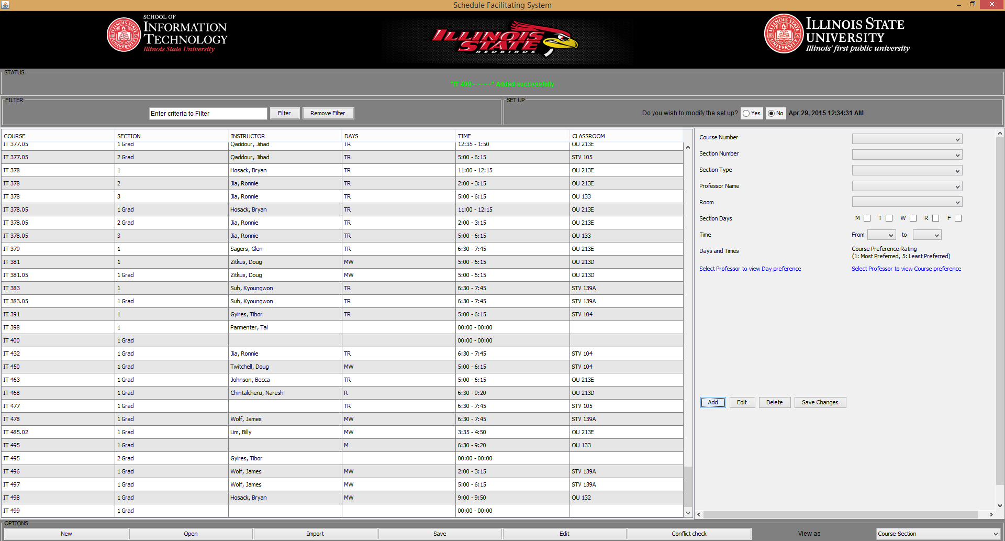

1. At the end, **Save Changes** by clicking the “Save Changes” button in the edit panel.



1. Afterwards, click “Save” at the bottom located in the “Options” panel.

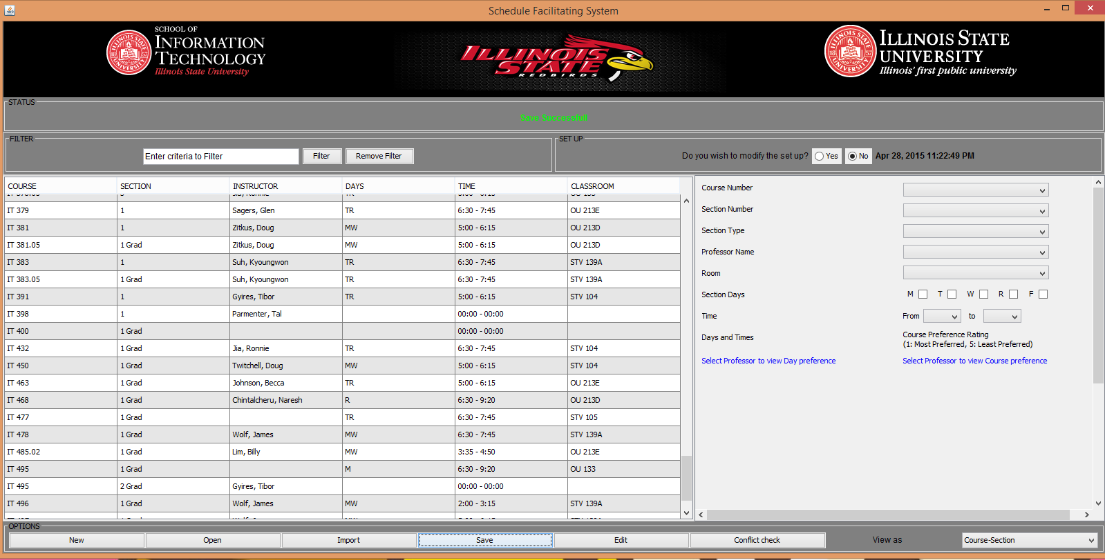

1. **Delete a row**, first select a row to delete.

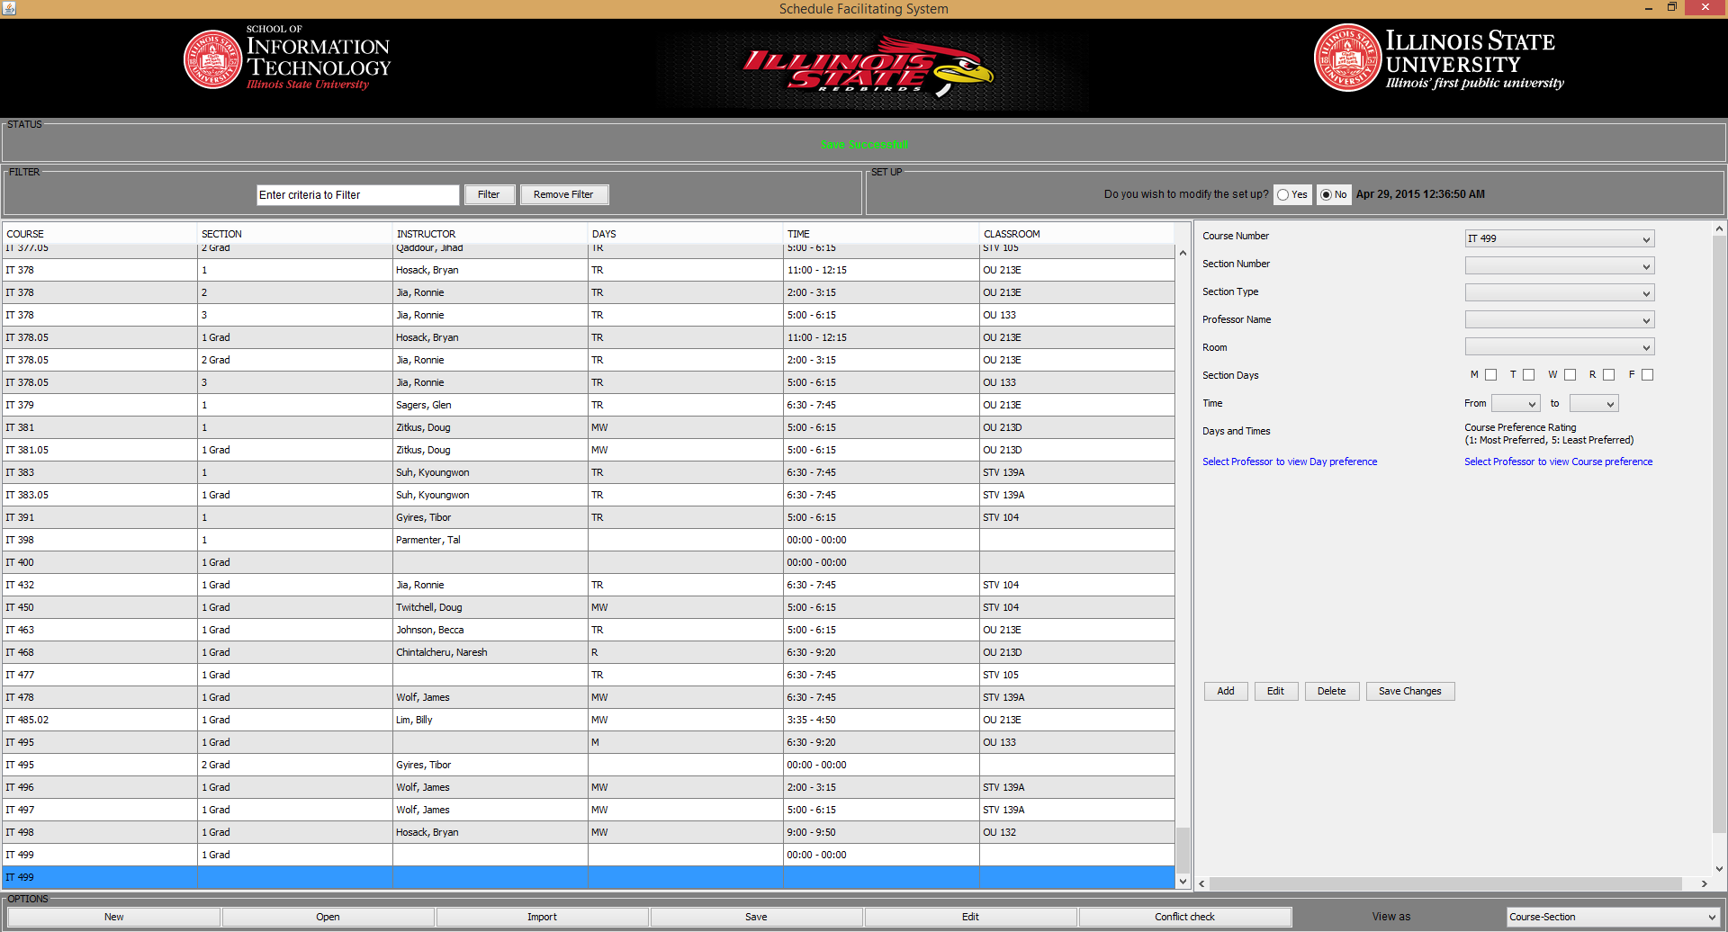

1. Then click delete.

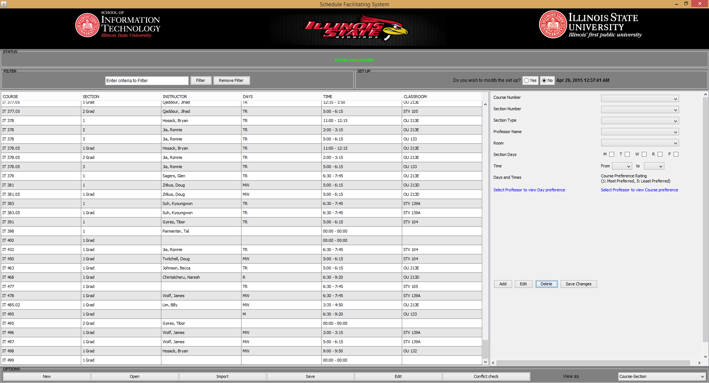

1. Repeat the **Save Changes** steps in **Add a course** above.

## Check Conflicts

1. (Assume Steps 1-4 from “Open a Schedule” are already done.) Click the “Conflict check” button located near the bottom in the “OPTIONS” panel.

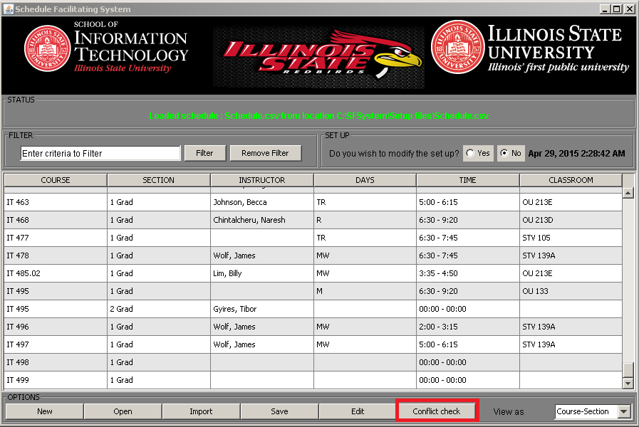

1. After you click “Conflict check” a pop up screen should appear.

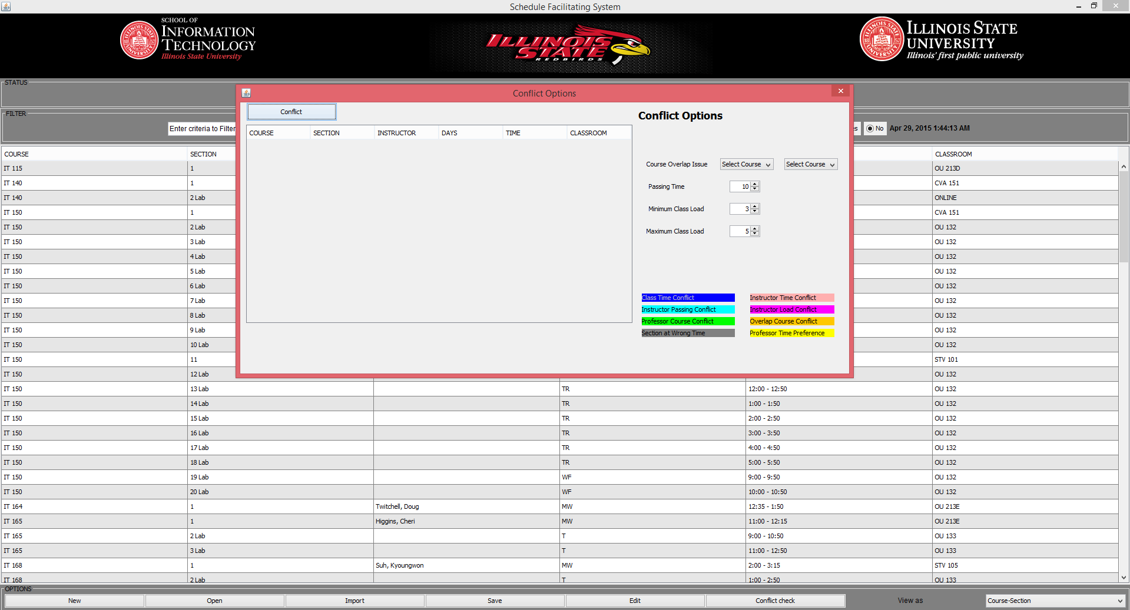

1. Then click the “Conflict” button in the upper left hand corner of the pop up menu. This button will display all of the conflicts which are nicely separated through color coordination.

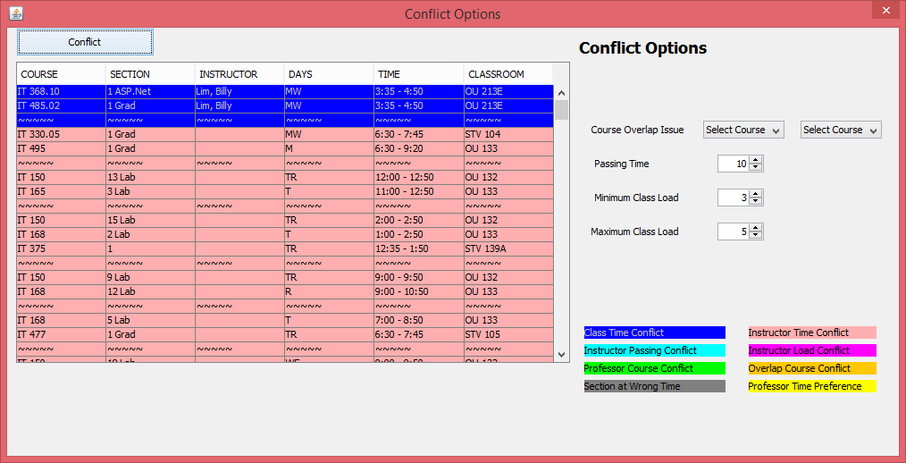

1. For even more convenience select a class under “Conflict Options” and that same class will be selected and shown in the schedule table.

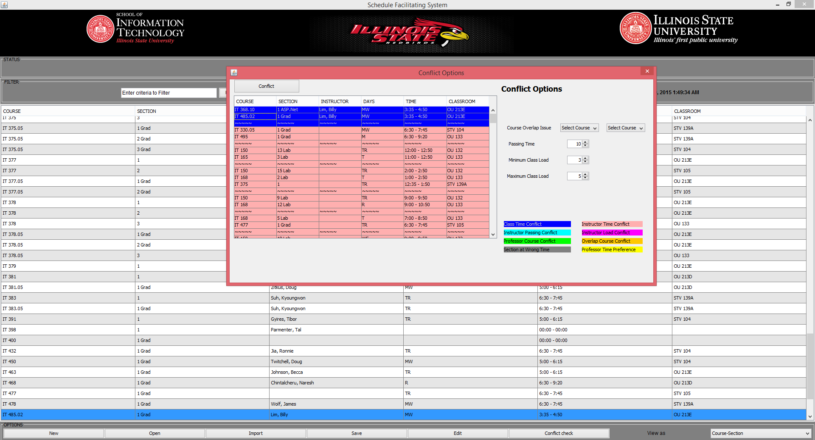

## Search

1. (Assume Steps 1-4 from “Open a Schedule” are already done.) Please enter a value under the “Filter” panel and in the textbox that says “Enter criteria to Filter”.

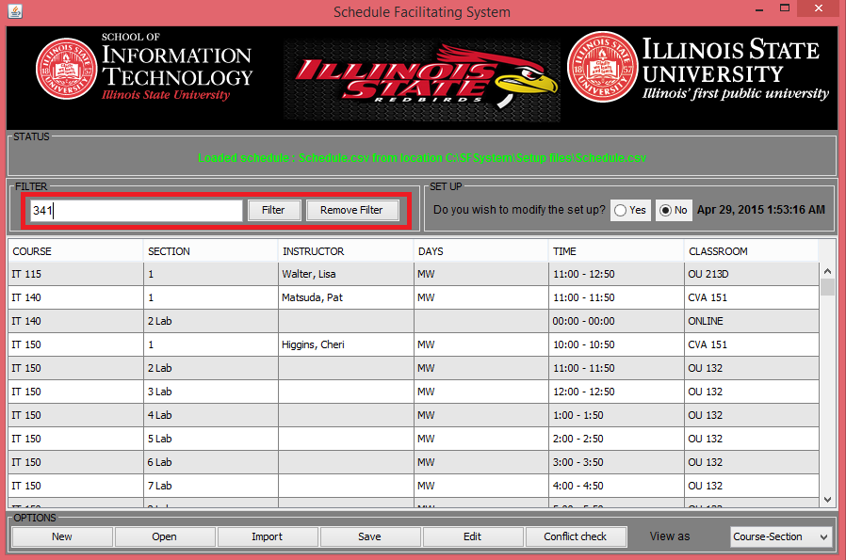

1. Next click the button “Filter” to view the results in the schedule table below.

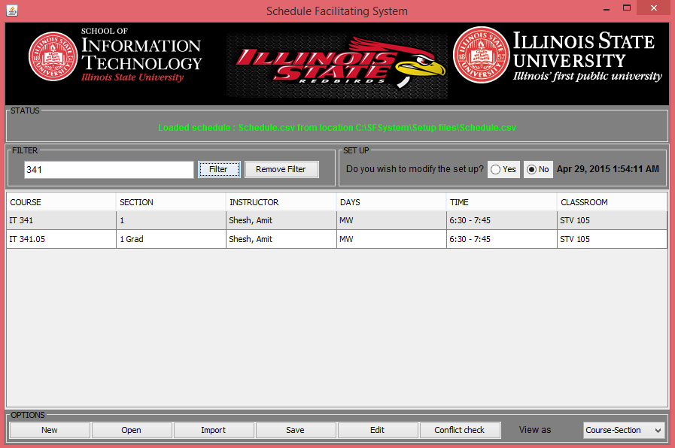

1. Click “Remove Filter” to go back to the original schedule.

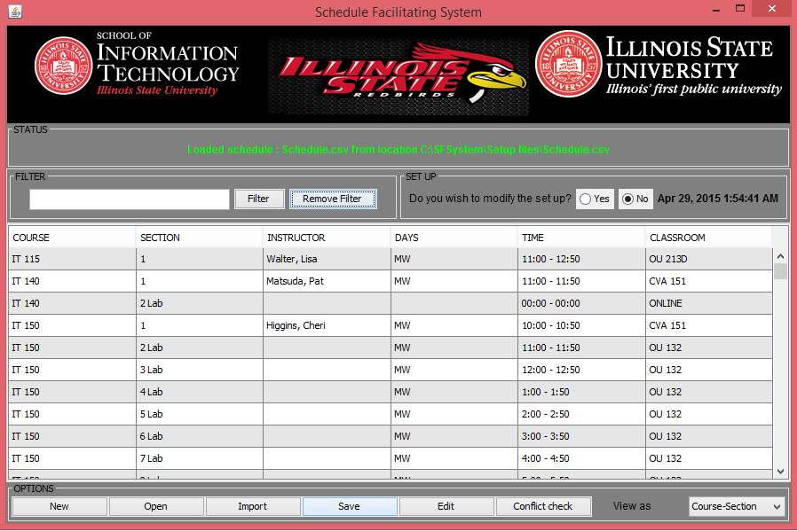

## Change Views

1. (Assume Steps 1-4 from “Open a Schedule” are already done.) Go to the bottom right hand corner and you will see that there is a drop down menu next to “View as”. There are 4 options present (Course-Section, Instructor-Assignment, Time-Table, & Classroom).

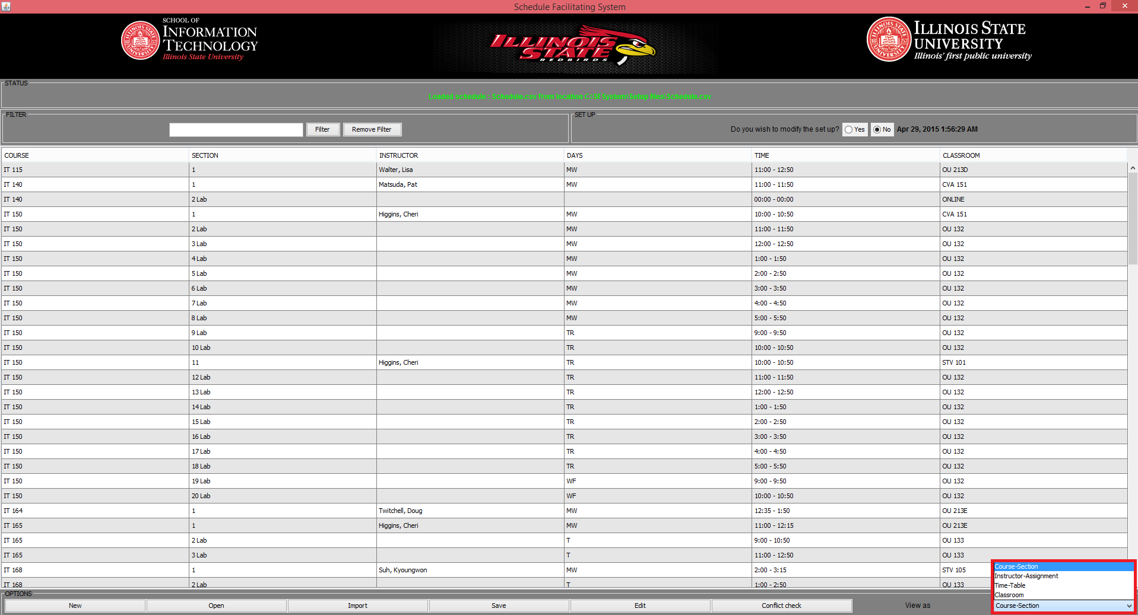

1. Instructor-Assignment View

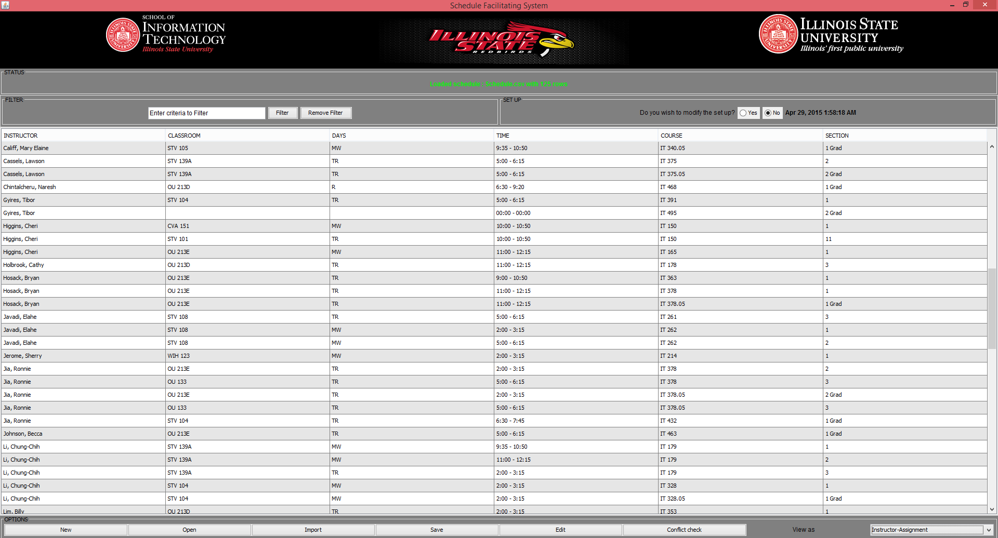

1. Time-Table View

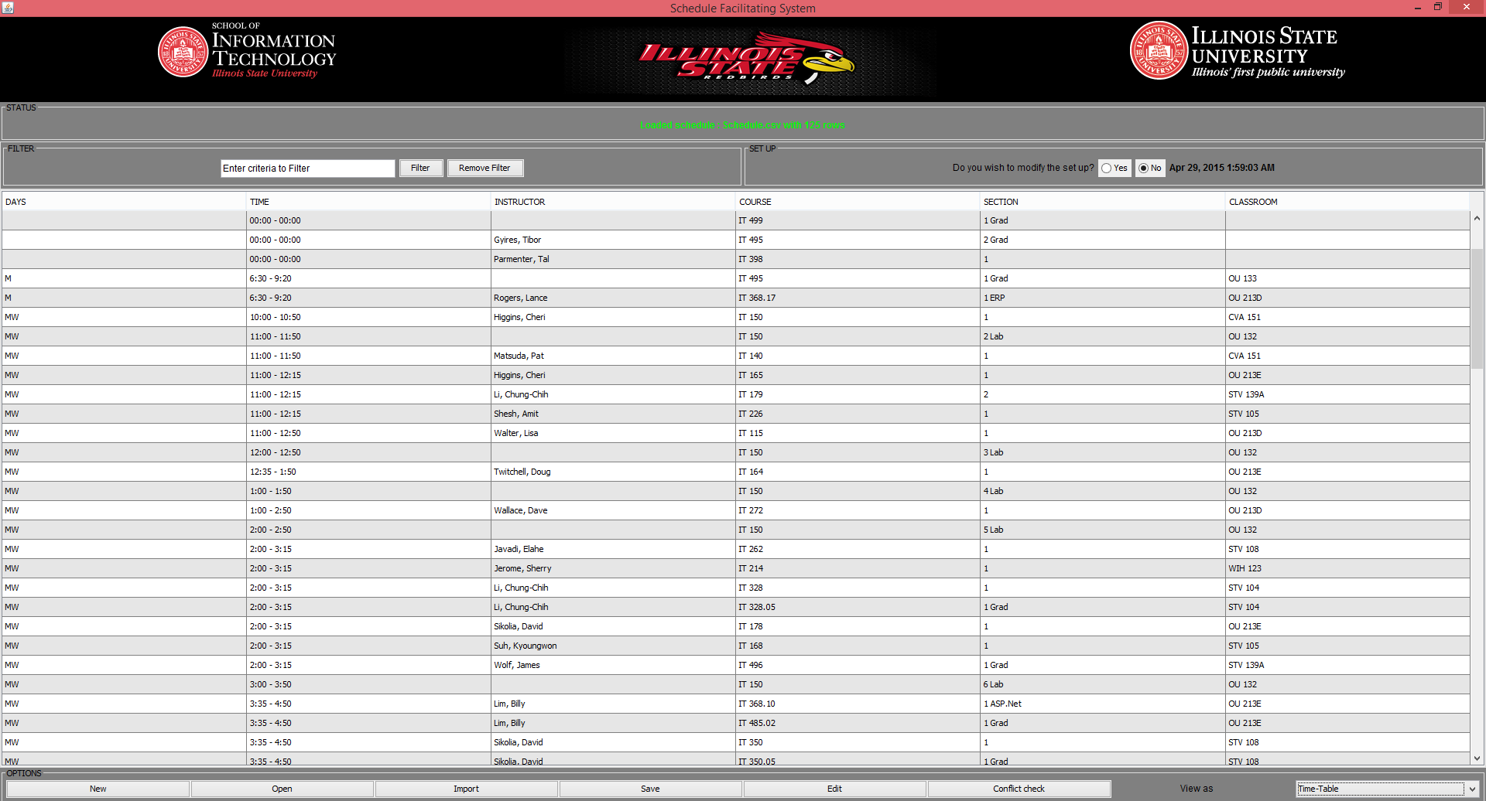

1. Classroom View (this view is according to days and classroom type)

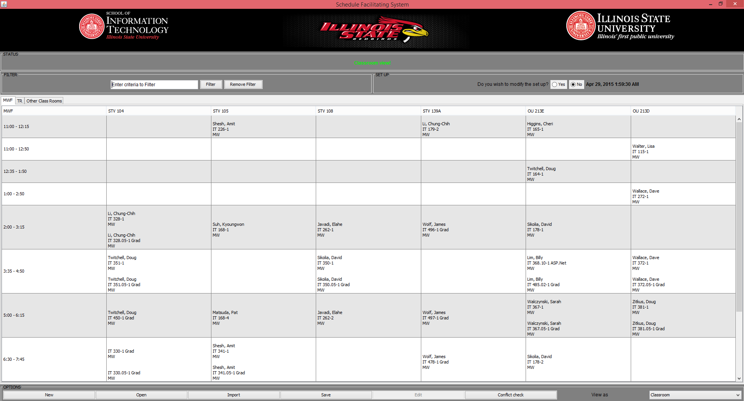

1. Also you can sort by clicking on the column names (it works the same for every view).

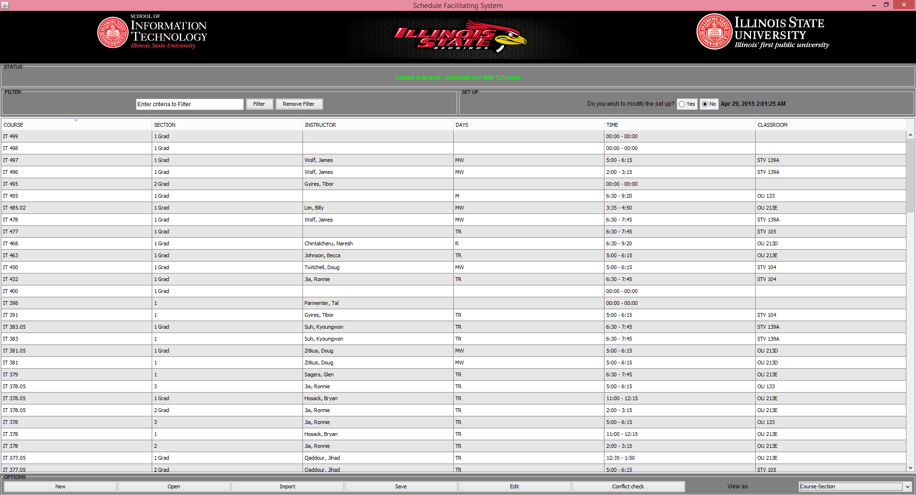

## Change the Theme / Theme Preferences and Style

1. Find modify and click the “Yes” button (just like how you would do for modifying your files).

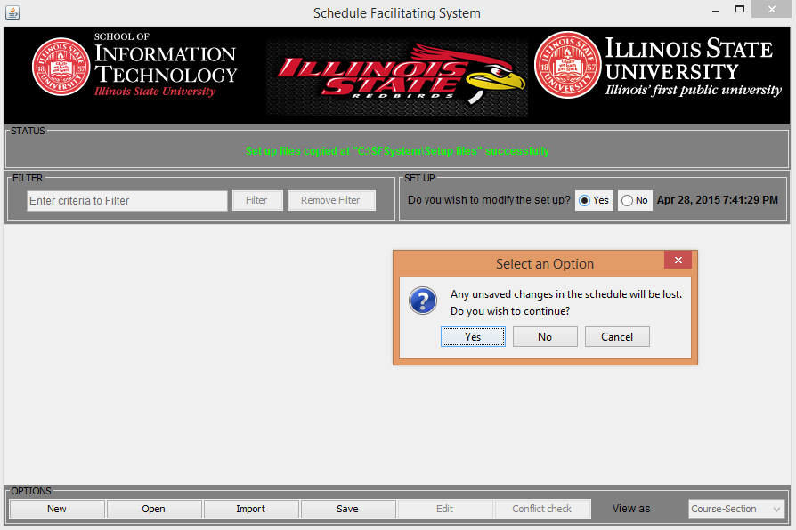

1. Please click “Yes” to continue. Afterwards, you will be brought to the modify window.

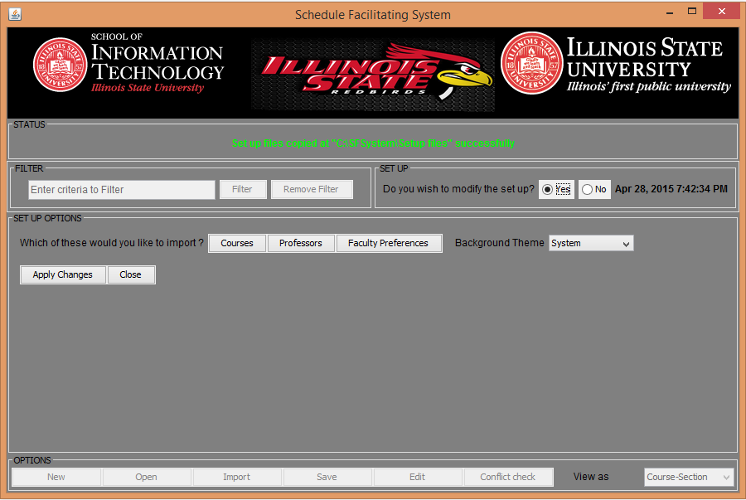

1. Click on the drop down menu next to “Background Theme”.

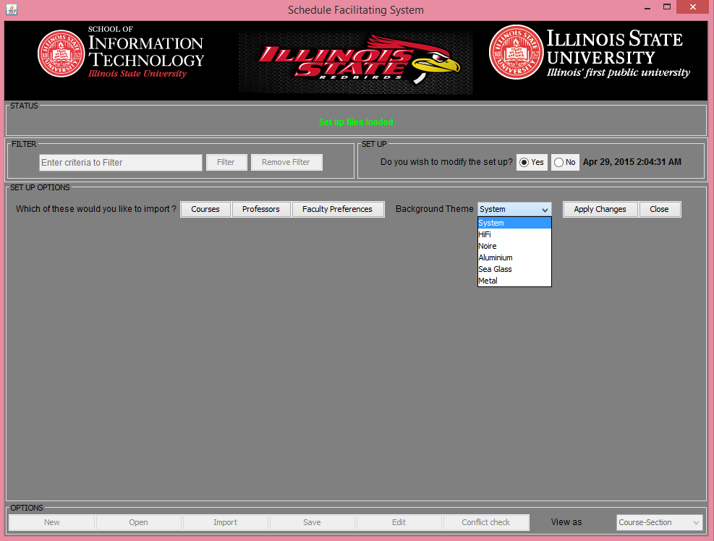

1. HiFi Theme

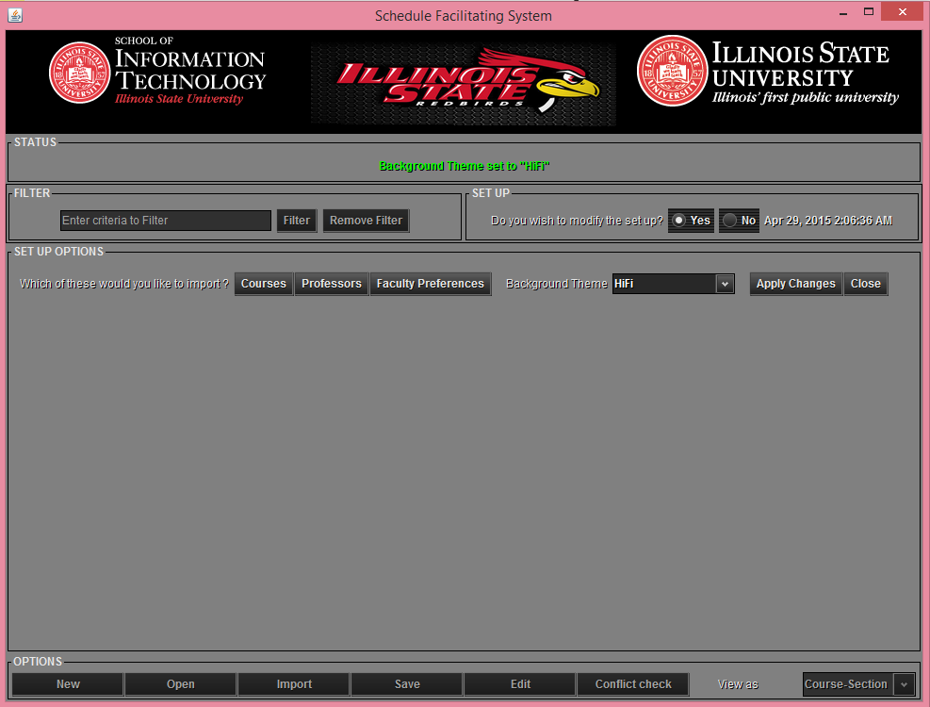

1. Noire Theme

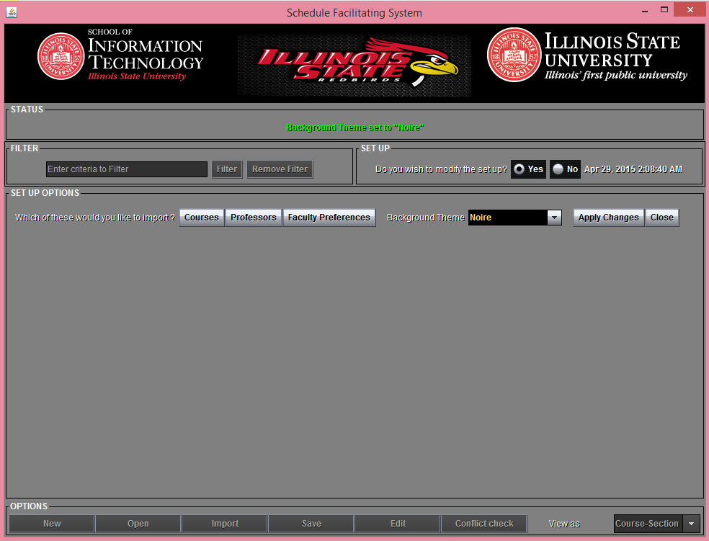

1. Aluminum Theme

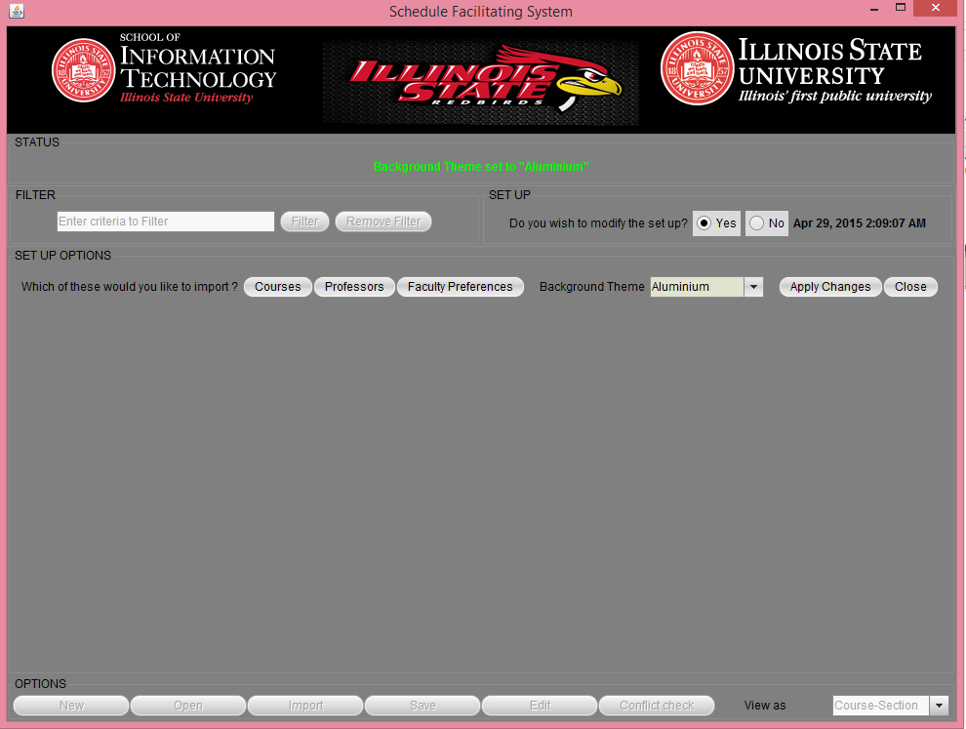

1. Sea Glass Theme

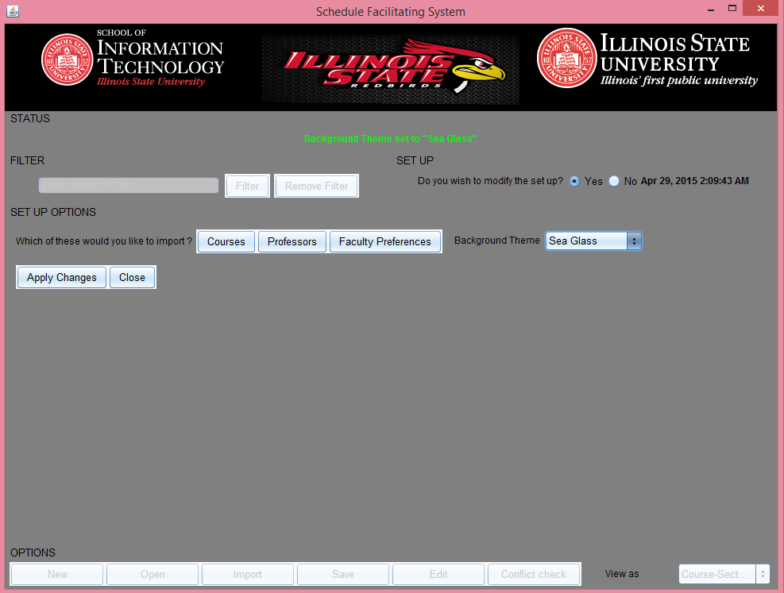

1. Metal Theme

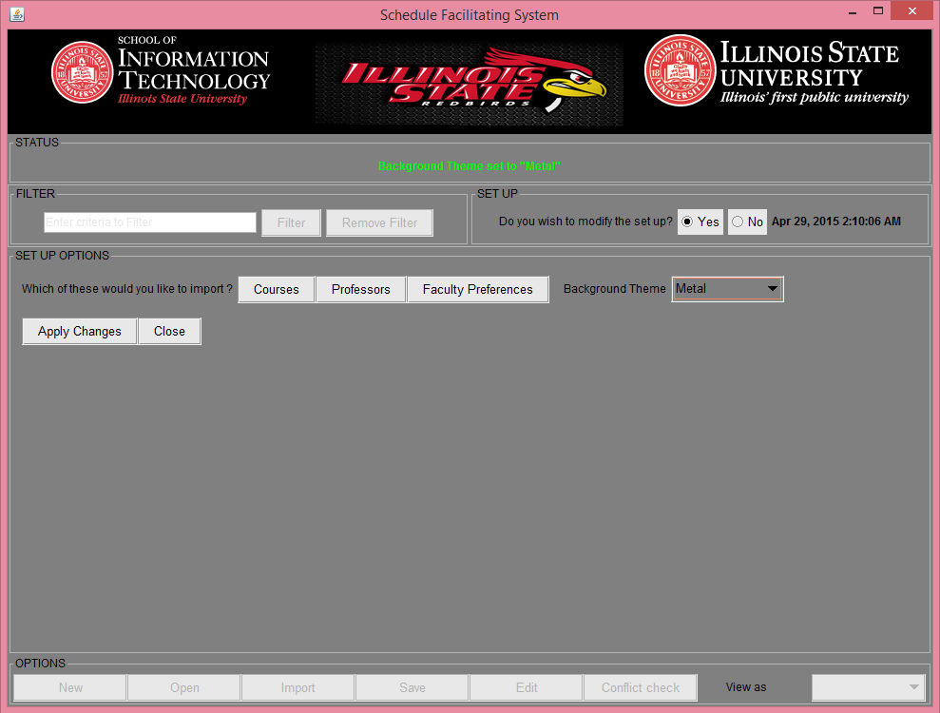

1. After you choose a theme that is to your liking, please click the “Apply Changes” button to apply the theme.

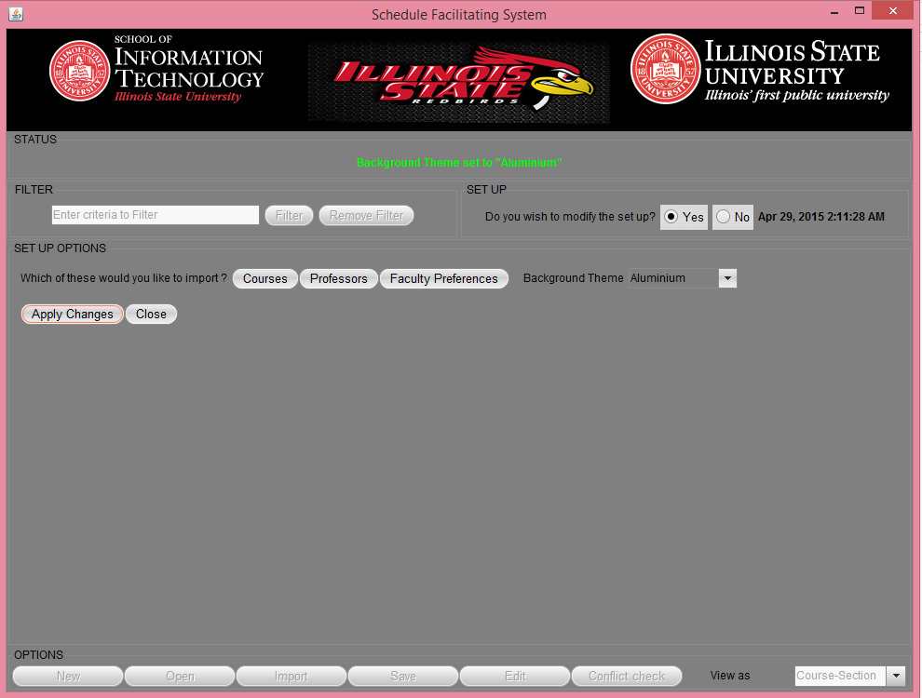

1. Afterwards click the “Close” button right next to “Apply Changes” for the new theme to work.

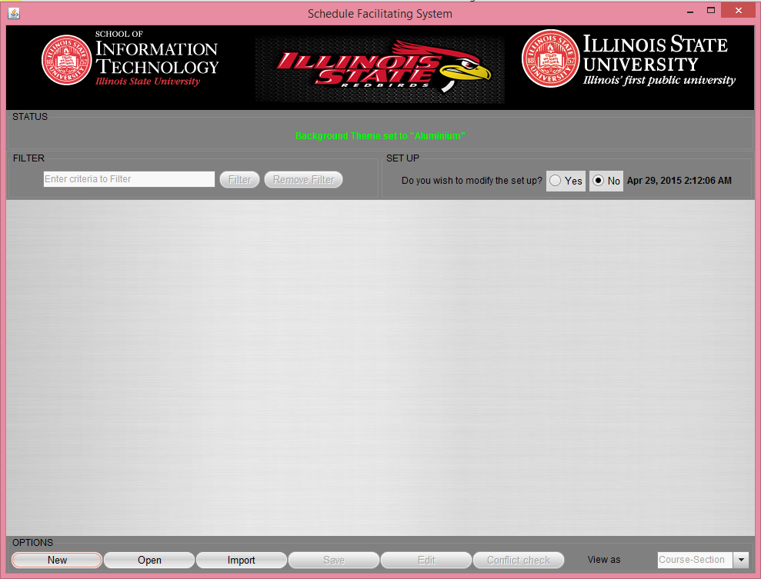

# Final Notes

Modify file(There are 2 ways to modify csv files using this application.)

* + First way: Modify any csv file in the “Setup files” folder, save the changes and close the editor you are using to make those changes (i.e. excel or notepad). Then run the “SFSystem” and your changes should be there in the edit section.
  + Second way: Run the “SFSystem”, identify the “Set Up”panel, and click the yes button for “Do you wish to modify the set up?”. A reminder will pop up and ask if you would like to continue, please click “Yes”. Under “Set Up Options” there will be 3 buttons named “Courses”, “Professors”, and “Faculty Preferences”. Please click the button that applies to the updated csv file you would like to import. It is necessary to note that the csv file name has to be the same as the file names in the “Setup files” folder. Equally, it is important to note that the updated csv file must not be in the same location as the “Setup files” folder. After you have selected the desired file, the status should show green colored text, which displays the location of the file you are importing with “imported” after it. Afterwards, please click the “Apply Changes” button, you will notice that the status bar shows green colored text, which now displays the name of the file. Lastly, please click the “Close” button.

1. The purpose of opening a schedule is if you would like to use an existing schedule you want to continue working on.
2. The purpose for import is to use an existing file as a template for a new schedule.